[PROJECT NAME]

Project Management Plan

Submitted to (Client representative’s name, title, organization)

Submitted by

Date Submitted

The information contained in this document is confidential to The Company Corporation and the above named client.

Table of Contents

Document Control 3
Project Definition 4
Background 4
Project Goal 4
Scope of Work 4
Proposed Solution 6
Project Assumptions and Constraints 6
Project Risk Management Plan 7
Project Issues /Action Items Management 7
Resource/Staffing Plan 8
Organization Chart 8
Roles and Responsibilities Chart 9
Work Breakdown Structure 10
Work Detail 10
Project Timeframe and Milestones 12
Cost Plan 13
Quality Plan 14
Test Plan 15
Change Control 16
Communications Plan 17
Training Plan 18
Project Document Management and Archive 19
Project Management Plan Approval 20
Appendix A. Change Request Form 21

Document Control
Revision | Date | By | Revision Description
Version 1.0 |  |  | Initial preparation of document
Version 1.1

Note: The Project Management Plan is based on the needs identified in the Requirements Document and other information provided by the client. The Project Management Plan is the combination of several documents and plans to form a detailed, coherent and interdependent descriptive narrative blueprint of the project.

General GUIDELINES for completing the Project Management Plan:
- The Project Management Plan is a self-contained document describing the project to anyone having to approve, support, or participate in the project and is a critical document for organizational alignment and bringing new team members up to speed.
- Scale the sections of the Project Management Plan to the magnitude of your project. Some sections and appendices may require only a few lines for small projects; for large projects, some sections may be several pages long, a separate document, or an entire manual.
- The Company Project Manager presents the Project Management Plan to the Client for their review and written approval.
Please note: Text or items in italics or in brackets are instructions for creation of the Project Management Plan and may be removed and substituted with relevant information. Delete items that do not apply

Project Definition
The Project Definition section is created to provide detail and the direction for the project execution.

Background
The background can include [1] the historical or business origins of the project; [2] a description of projects that may affect or may be affected by this project, including projects that must be underway or completed before this project can be completed successfully; and [3] a description of the work being done by other departments upon which the work of this project depends. It may also state major assumptions about the relationship of the project and other projects and on-going work.

Project Goal
What goal does The Company hope to achieve by implementing this project? How is the system projected to evolve over a given time period is important in order to ‘future proof’, the system as much as possible. Does The Company plan for follow-on projects? The Project Goal should be a one-sentence statement of the purpose or goal of the project.

Scope of Work
It is the single most important item of the project and is the reason the project exists.

The Scope of Work is a statement where you clearly define the boundaries of your project, provides a summary of the business and technical scope of the project, and states the reason or reasons for the existence of the project. The purpose of the Scope of Work statement is to clearly delineate work to be done during the project (in scope) from work NOT to be done during the project (out of scope) in terms of the end product or services as defined by:
- The types of deliverables that are in scope and out of scope (business requirements, current state assessment)
- The major life-cycle processes that are in scope and out of scope (planning, analysis, design, implementing, testing)
- The types of data that are in scope and out of scope (financial, sales, employee)
- The data sources (or databases) that are in scope and out of scope (billing, general ledger, payroll)
- The organizations that are in scope and out of scope (human resources, manufacturing, vendors)
- The major functionality that is in scope and out of scope (decision support, data entry, management reporting)
The Scope of Work states the purpose and direction for all objectives, work activities, and tasks; and their alignment with the overall business goals. This section should identify the client, service providers, description of the work to be performed, the deliverables, the location, the net results of the work done, and the capabilities of the new application or installation.

In Scope
Provide information on all items within scope of the project. The items should be stated as objectives and should be specific, measurable, assignable (to a person), realistic, and time-related. The project is completed only when all objectives are accomplished. Objectives can be stated in terms of:

Business Objectives
Specific and realistic business goals, financial goals, business requirements to be met, regulatory requirements to be met, and problems to be solved by new hardware or software.

Technical Objectives
Describe the specific functional, technical, or operational goals of the project deliverables and technical requirements at a high level in measurable terms along with the technical advantage or improvement gained by the completion of the deliverables.

Out of Scope
Provide information on all items outside the scope of the project.

(Example 1)
The Company will provide the following services as part of the project:
- Project Management including change, scope, schedule, and cost control as well as issues management
- Network Design and IP addressing scheme
- Project Documentation to include Project Management Plan, Project Schedule, Network Design, Installation Plans, and Cutover Plans
- Physical Installation of new network equipment and documentation where required
- Installation of the agreed on network management tool

Upon project completion, the Client will have an operational network per the design with complete network documentation.

(Example 2)
Network Design and IP Addressing Scheme
The Company will work with Client personnel to develop a comprehensive network design including the quantity of equipment, equipment placement, and an integrated IP addressing scheme for all of the Client's legacy and new sites. The Company, working closely with Client IS staff, will perform this work and The Company will draw from resource pools responsible for designing and certifying complex networks as needed.

Project Schedule, Installation and Cutover Plans
The Company will develop a project schedule including key milestones. The Client and The Company will be able to use this plan to know on any given date what part of the project is completed, what the next steps are, the personnel assigned to these tasks, and any open issues that need to be resolved. The Company and the Client will also develop Installation and Cutover plans for those phases of the project allowing coordinated planning and the least possible disruption to current users.

The Company personnel will configure all new equipment, test the equipment for proper operation, and then install the new equipment, insuring operational integrity with, and minimum interruptions to the existing network.

Documentation of New Network
Upon project completion, The Company will provide the Client with Visio diagrams of the new networks including IP addressing scheme. This documentation will consist of both a master view of the entire network and then of subset views broken out by building.

Additional Services
The Company will provide the following services as part of the project:
- Project Management including change, scope, schedule, and cost control as well as issues management
- Project Documentation to include Project Management Plan, Project Schedule, Project Design, Installation and Cutover Plans
- Training to end users for the new report creation and output

Upon project completion, the Client will have an operational report per the design with complete documentation.

(Example 3)
The Company will work with Client personnel to develop a comprehensive report design including input data and report format and usage. This work will also include a plan to use the report at all of the Client's legacy and new sites. The Company staff, working closely with Client staff will perform this work and The Company will draw from personnel resource pools as needed for the duration of the project.

Proposed Solution
Provide a high-level outline for the proposed solution including:

Functional Performance Specifications
State the functional performance specifications based on the client’s list of characteristics of the deliverables that will address their business needs. They include product features, function changes, and work environment changes.

System Performance Specifications
State the system performance specifications, which include the minimum system features that must be in place for the deliverable(s) to function effectively when completed.

Security/Protection
Describe how the project might affect the security of existing or proposed environments, such as data, technical, personnel, or others. Identify requirements for redundancy or backup.

Project Assumptions and Constraints
Project assumptions are circumstances and events that need to occur for the project to be successful but are outside the total control of the project team. Identify the assumptions used in formulating the project plan, cost estimates, project schedule (e.g., availability of personnel, quality of available resources, availability of technology). Identify the assumed role of the clients and users in testing, training, rollout, and post-implementation. Identify other projects or tasks related to the project that may need to be done as a prerequisite to this project. Include projects the failure of which may affect this project’s cost, schedule, scope or requirements. The Cost, Schedule, and Performance Priority may be useful ways of laying out major assumptions.

A project constraint is a restriction that will affect the performance of the project such as a regulatory, budget, or contract constraint. The constraint forces the project to be planned and executed within boundaries.

(Example)
The following assumptions should be understood by the Client regarding this Project:

- This Project Management Plan, along with other project documents is intended to ensure timely implementation of project deliverables.
- The Client will ensure that appropriate building access is provided to The Company personnel for the duration of the project.
- The Client is responsible for all equipment and applications not specifically noted in the scope of work.
- The Company is responsible for implementing and managing the Project Change Control process.
- The Company is responsible for implementing and managing the technical escalation and resolution processes.
- The Company expects the Client will make any modifications outside the scope of this document.
- Per this agreement, The Company makes no warranty not expressly stated in documentation provided.
- This Project Management Plan does not serve as a warranty, nor does it in any way add to any written or non-written warranty provided elsewhere.
- The Client and The Company will be responsible, jointly and severally, for assuring that the Project Management Plan and Project Schedule are adhered to as closely as possible. Any changes will be processed and approved through the Project Change Control Process and be made part of this document through amendments to the Project Management Plan (e.g. Change Orders).

Project Risk Management Plan
After performing a risk assessment and management plan, list here the significant risks or factors that may affect the project’s schedule, cost, requirements and scope. If you list any item of risk, you must also include the risk management plan along with the risk triggers and impact. The Company project manager is responsible for identifying and tracking risks and issues during the project. These risks and issues will be regularly reviewed during the weekly status meetings.

If a contingency plan is called for, establish the priorities for mitigating risks and the threshold limits that trigger contingencies. Steps to prevent or mitigate the impact should be clearly defined.

(Example)
Risk Assessment is a formal process to identify, analyze, plan, track, and control risks related to implementing software. There are potential risks associated with any project that need to be addressed via mitigating activity. The following table summarizes potential risks identified by the Core Team, possible impacts, and recommended mitigating strategies.

Risk and Trigger | Impact | Mitigating Strategy
Client is undergoing a major re-architecture of their network environment, which may delay the installation of the proposed environment until late November. The trigger includes any major slippage of the re-architecture project schedule. | Pilots and workshops would need to be conducted in a different environment, or the project could be delayed until the proposed environment is installed. | The Company and the client will research the possibility of creating a special pilot environment for use during workshops and pilots.
The proposed project must be coordinated with HR initiatives and changes taking place. | Project delays could occur while decisions are made and HR direction is determined. | The Core Team will work very closely with the principals of the HR initiatives to coordinate both projects.
Rollout of project disrupts the client’s normal business operations | Lost revenue and utilization. | Proper implementation of business processes, adequate testing, effective end user training, and positive, consistent, and aggressive communications.

Project Issues /Action Items Management
All business, technical, legal, environmental, personnel (etc.) issues arising during the project will be tracked in the Issues/Action Item Matrix and managed by the project manager to resolution. The Issues/Action Item Matrix will be an agenda item for every status meeting. Some risks from the Risk Assessment and Management plan may be moved to the Issues/Action Item Matrix to be actively managed during the lifecycle of the project.

Resource/Staffing Plan
The Resource Plan identifies the people, materials, and equipment required to accomplish the project and should:
- Identify skill sets required for the major components of the project (work with the Project Schedule).
- Provide a Skills Matrix showing skill sets required for each major component of the project.
- Provide the roles and responsibilities of all personnel involved with the project.

Organization Chart
Create an Organization Chart showing as much detail as possible. The chart should clearly depict reporting relationships among the team members. It should include the individual’s name, title, department, phone number, and fax number.

(Example)

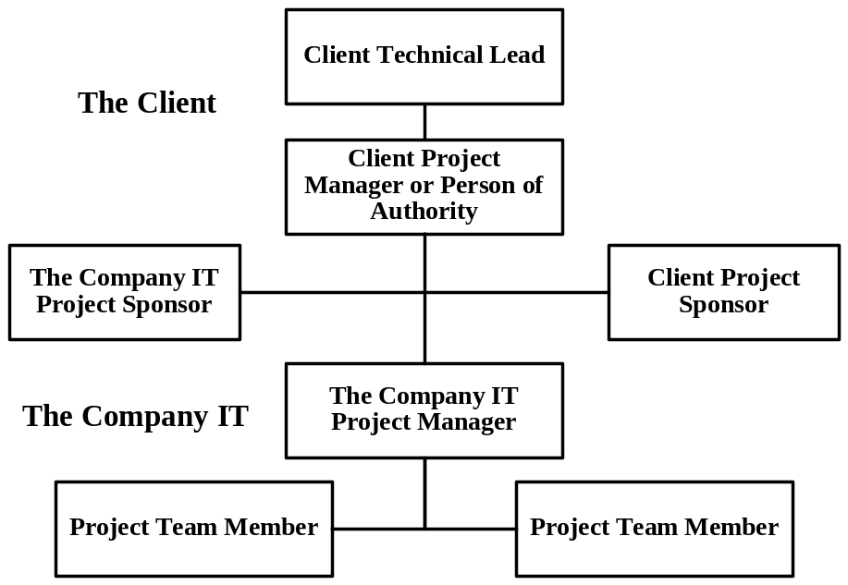

Roles and Responsibilities Chart
(Example)
Client Personnel
The Client management team will designate one (1) Person of Authority with decision-making authority and one (1) Technical Lead for the entire project. The Client Person of Authority must approve all Change Orders. Should the dollar amount exceed the signature authority of the Client Person of Authority, additional approvals will be required. The Client Person of Authority will interface with The Company Project Manager and will be available throughout the duration of the project. The Company Project Manager and the Client Person of Authority will jointly make all major go/no-go decisions during the project.

The Company Organization
Name – Title | Project Responsibilities
Name – Location  Project Sponsor | The Project Sponsor will act as The Company’s internal Sponsor to the Project. The role of the Sponsor is to monitor progress and to provide support to the Project Manager should additional resources be required at any stage during the Project.
Name – Location  Project Manager | The Company Project Manager is the prime interface for the Client throughout the project implementation period. The Project Manager will manage all day-to-day activities and control all resources necessary to meet the defined requirements and deliverables of the project including the management of Change Control and Technical Escalation. The Company Project Manager and the Client Person of Authority will jointly make all major go/no-go decisions during the project. The Company Project Manager will be available throughout the active periods of the project.
Name – Location  Project Team Member | The Project Team Member will be responsible for design and implementation of the project under the management of the Project Manager. Specifically, the Project Team Member is responsible to provide initial and final design, utilizing other resources from The Company as necessary. The Project Team Member also builds, tests, trains end users, and implements the solution called for in the project objectives. The Project Team Member will also be responsible for technical documents during project implementation. The Project Team Member will be available throughout the project.
Name – Location  Personnel Manager | The Personnel Manager will provide project resources to the project.

As is the case in any major project, unplanned situations will arise and issues will need to be resolved without having been firmly defined by contract or Project Management Plan. It is very important that The Company and the Client understand this dynamic, plan for it, and use good judgment, realistic expectations and common sense when determining roles and responsibilities. The Company is committed to the success of this project and will use its best commercial effort to ensure total client satisfaction in all facets that fall within our purview.

Work Breakdown Structure
The work breakdown structure is based on current information. As the project progresses, there may be further refinements and greater detail.

The work breakdown structure (WBS) is a hierarchical outline of major work categories that are subdivided into manageable pieces or individual tasks (work packages). Each work package is described in sufficient detail to clearly communicate the characteristics for satisfactory completion of the work package.

(Example)
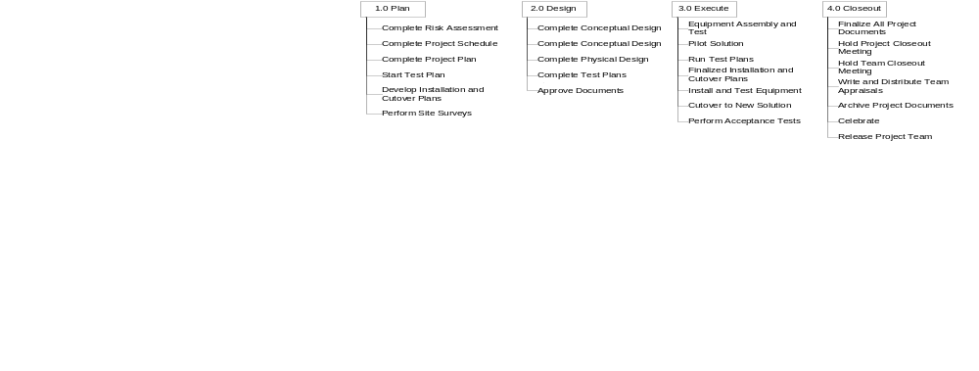

Work Detail
(This section is optional, but recommended for clarity)

Plan Phase
The goal of the Plan Phase is to gather project information, turn that information into working documents including design, and gain signoff to proceed with the project.

During the Plan phase, the Client shall:
- Collaborate with The Company to:
  - Provide requirement information to help define the project.
  - Define goals, objectives, assumptions, constraints, and timeframes for the project.
  - Define constraints for network cutover.
  - Define project acceptance criteria.
  - Work with The Company to create detailed Test, Transition, and Contingency plans
  - Identify critical implementation target dates and contingency plans if those targets are missed.
- Identify current environment elements that may impact the proposed solution.
- Provide a list of key Client contacts along with e-mail addresses, phone, pager, and other numbers to enable them to be contacted for the duration of the project.
- Inform The Company of possible trouble areas (specific situations that have caused problems in the past) and identify critical areas (servers, links to the WAN, etc.).
- Notify all end users, with a minimum of two weeks lead-time, for any project-related outage or interruption

During the Plan phase, The Company shall:
- Provide a list of The Company contacts along with e-mail addresses, phone, pager, and other numbers to enable them to be contacted for the duration of the project.
- Prepare initial project design documentation:
  - Project Design
  - Project Management Plan (this document)
  - Project Schedule listing target dates and milestones.
  - Change Control process and documents
- Collaborate with the Client on design and implementation issues.
- Finalize design solution.
- Finalize project documentation in preparation for implementation.
- Work with the Client personnel to develop and deliver detailed Installation and Cutover schedules.
- Work with the Client to develop detailed Test, Transition, and Contingency plans.

Implementation Phase
The goal of the Implementation phase is to build, test, train end users, and implement the final solution per the project objectives.

During the Implementation phase, the Client shall:
- Approve, or ask for modifications to, the documents presented by The Company during the previous phase.
- Work with The Company to approve any design modifications after testing.
- Be responsible for all equipment and applications outside the scope of this installation.
- Provide advance notification to users about cutover dates and scheduled outages.
- Assist The Company with testing.
- Be responsible for end users migration to the new solution.
- Provide the Client Person of Authority availability via pager, telephone, or onsite for all critical milestones.

During the Implementation phase, The Company shall:
- Approve, or ask for modifications to, the documents presented by the Client during the previous phase.
- Create final report per project objectives.
- Perform Tests per the Test Plan
- Prepare and report on all test results
- Work with the Client to gain approval of any modifications shown necessary during testing.
- Train end-users per the scope of the project.
- During the Cutover, The Company will provide support and problem resolution to address project-related problems.
- Provide The Company Project Manager availability onsite.
- Provide specialist at the beginning of the next business day to assist with any problem resolution related to new solution.

The Project Manager in coordination with the official from The Client, as named above, will make all major go/no-go decisions during this phase.

Acceptance and Project Review
- The new network shall be automatically accepted after seven (7) days continuing operation unless The Client indicates to The Company project manager in writing of any failure.
- Up until project acceptance, the The Company Project Team will provide support and problem resolution. Once the project is accepted, The Client is responsible for maintenance on the completed solution.
Examples:
- At minimum, Acceptance is based on successfully performing network “pings” between equipment and FTP file transfers between servers and test equipment.
- Acceptance is based on successful test completion of Use Case tests on identified modules during application development.

The Project Review will always be completed at the end of the project but may in addition be invoked during the completion of a Phase/Site. Activities will include:

- Client Review (Client Satisfaction)
- Technology Review
- Project Team Review

After acceptance, this project will be subject to review by the The Company Management.

Project Timeframe and Milestones
Complete a Project Schedule based on the Work Breakdown Structure and the Staffing and Resource Plan that will include key milestones, start dates, end dates, duration, and resources to be used for project completion. Show the dependencies between major project components. Use Microsoft Project or other Project Scheduling tool and level the project. You can present the output of a project-scheduling tool as the Project Schedule, but list major milestones in this section.

The Client and The Company will be able to use this plan to know on any given date what part of the project is completed, what the next steps are, the personnel assigned to these tasks, and any open issues that need to be resolved. The Company and the Client will also develop specialized plans if called for in the project objectives.

Cost Plan
(This section is optional if you have a separate Cost Plan document)

The Cost Plan is based on the Work Breakdown Structure (WBS). It includes cost estimates for all resources for which The Company is responsible. This includes employees, contractors, consultants, materials, equipment, and supplies. The costs are estimated at the work activity level of the WBS. Any contingency and assumptions used in developing the estimate are clearly identified. The cost plan is summarized by time period on an incremental and cumulative basis.

Quality Plan
For large projects, a Quality Plan is essential. The Quality Plan includes documents outlined in this “Project Administration” section and the forms or instructions used to manage these functions. Identify the architectural, hardware or software standards that apply. Identify technical and client reviews necessary to ensure quality.

(Example)
The satisfaction of the project stakeholders greatly depends on the application of quality guidelines created to guide the planning and execution of the project deliverables. The purpose of the quality management plan is to ensure that the project quality objectives and stakeholder expectations are met and to ensure that the products and services provided conform to the Project quality objectives.

Each assignment and deliverable owner will be responsible to meet the quality requirements of the client including criteria of acceptability. The assignment or deliverable owner must immediately notify the project manager if at any time during project execution the criteria of acceptability could, in their judgment, be considered to be in jeopardy.

The Company senior management allocates a qualified resource to audit all project deliverables during project execution. This is performed to ensure that variance between expected and inspected quality results meet the defined criteria of acceptability for each deliverable. If any problems are identified during the audits, the person providing the audit will provide a complete description of the problem and root cause if determined, along with a proposed solution and its expected impact.

The change request form will be used when changes are deemed unavoidable but necessary to ensure quality results. The change request allows the team to identify and communicate changes to the project quality. The project manager is responsible for authorizing preventive, corrective and change requests. He/She has the overall responsibility of negotiating concessions or tradeoffs that result from quality variances with the project stakeholders.

Test Plan
For large projects, a separate Test Plan is required. Describe the testing that The Company is committed to perform. Name tests for which the client is responsible. The names of the tests should also be in the Scope of Work (either in-scope or out-of-scope for The Company). Identify the test results review process, follow-up actions, and sign off.

Change Control
Describe the process to identify the need for change in project scope, requirements, schedule or budget. Describe the steps in the change approval process, including those whose input or approval is required. Identify the kinds of changes, if any, that are exempt from the change approval process. Describe how changes will be documented and communicated to clients, team members and stakeholders.

(Example)
If a change is requested by the Client that significantly alters the plan, design, topology or implementation strategy; that change will be delivered to The Company Project Manager in writing on a Change Control Document. Change Orders will be accommodated, if possible, if there is no cost to The Company, subject to approval of The Company Project Manager. Costs to The Company include, but are not limited to, use of resources, use of time (delay), or use of capital or tangible goods. The Company Project Manager will return the Change Control Document within five (5) working days with a description of any impact of the project timeline, any additional costs, and any impact on the project scope.

The Change Control Document will then be signed by the Client Person of Authority and implemented if required. This document will be considered as approval to implement the change. The Company Project Manager has final authority to decide all Change Order issues. A Change Order may result in a contract addendum and/or a separate Purchase Order to cover modification or change.

Communications Plan
Describe the formal and informal means you will use to communicate with clients, stakeholders, team members, users and others. Identify the objective of the communication. Identify the events that will require communication with stakeholders, etc. and their frequency. A Communication Plan is required on large projects. Include status reporting, meeting and e-mail protocols.

Communications  Required | Frequency | Owner | Output
Project Status Meetings | Weekly on stated day of the week | The Company Project Manager | Agenda and Minutes to be produced by The Company Project Manager. Both The Company Project Manager and Client Person of Authority to ensure availability of all participants.
Project Logs | Daily | The Company Project Manager | Each team member will fill out his or her project log on a daily basis. The Project Manager will consolidate to a Project Status Report weekly.
Project Status Reports | Weekly | The Company Project Manager | The Project Manager will consolidate daily project logs to a weekly Project Status Report
Project Documents | As generated or modified | The Company Project Manager | Output made available to The Company project personnel and Client Person of Authority
Technical Reports | As generated or modified | The Company Consultant | Output made available to The Company project personnel and Client Person of Authority through The Company Project Manager.

Weekly Project Status Meeting Agenda

DISTRIBUTED TO: (to be completed and owned by The Company Project Manager)

- Progress against the Project Schedule (Use Project Schedule for update)
  - Major accomplishments for past week
  - Goals for next week
- Issues Review and Closure (Use the Issues Matrix for update)
- Future Project Team Meeting Dates

Training Plan
(This section is optional, and is only needed if client training is required for successful acceptance of the project. Track client training to ensure compliance.)

 | People
Product | Name | Name | Name | Name
Enter Product | When Available  When Scheduled  When Taken | When Available  When Scheduled  When Taken | When Available  When Scheduled  When Taken | When Available  When Scheduled  When Taken
Enter Product | When Available  When Scheduled  When Taken | When Available  When Scheduled  When Taken | When Available  When Scheduled  When Taken | When Available  When Scheduled  When Taken
Enter Product | When Available  When Scheduled  When Taken | When Available  When Scheduled  When Taken | When Available  When Scheduled  When Taken | When Available  When Scheduled  When Taken

Project Document Management and Archive
Documents produced for this project will be made available to all people within the Project environment (including the Client/partner/Integrator/The Company). A hard-copy version of the project documentation will be produced and delivered to the Client’s Person of Authority noted above.

All documents will reflect the current issue status, document author, and page numbering. The project documentation will be kept for a period of the project duration plus (5 years).

The Project Schedule and Issues Matrix will be updated as necessary during the project. The most current version will be distributed to the project team.

Project Management Plan Approval
(Optional, but recommended)
The Project Management Plan Approval allows the client to indicate approval of the project plan. The best way to get written approval from the client project manager is to review the Project Management Plan with them together in a face-to-face meeting, record any last minute exceptions on the form and ask them to sign it. The Project Management Plan Approval form is the formal document recording the client's approval and The Company' commitment. It is not the Engagement Agreement.
The undersigned agree to implement this Project Management Plan for the [PROJECT NAME], as revised from time to time in accordance with the Change Management Plan herein.

________________________________________________ ____________________________________________
Client Name Printed Name

__________________________________________________________ _______________________
Client Title Date

Exceptions and changes:

Initials:

________________________________________________ ____________________________________________
[The Company Representative] Printed Name

__________________________________________________________ _______________________
Title Date

Exceptions and changes:

Initials:

Appendix A. Change Request Form
Customer/Project Name:

Instructions: The Request portion of this form is to be completely filled out by the requester and delivered to the Project Manager. The Project Manager will research the impact to the project timeline as well as any cost or resource impact and complete the Impact portion of this form. The approval authority for the project will then sign the Approval portion before any work can take place and return the form to the Project Manager for action. The Project Manager will take appropriate action to implement the approved Change Request, document the change in the Work Record portion of this form, and make any required adjustments to the timeline and financials. This completed form will be retained as part of the permanent project file.

Request (completed by requester)
Author:
Date of Request:
Change #
Title of Change:
Description of Change:
Reason for Change:
Hardware Required:
Software Required:
Action Required:
Target completion date:
Change Requested by:
(Signature)

Impact (completed by Project Manager)
Timeline Impact:
Cost Impact:
Overall Impact:
PM Approval Recommendation: | ( ) YES ( ) NO (Tick As Appropriate)
PM Comments:
Project Manager:
(Signature)

Approval (completed by client’s approval authority)
This Change Request is approved, and the Project Manager is authorized to adjust timelines, costs and resources as noted above.
Company Approval
Change Approved by:
Date:
(Signature)
Client Approval
Change Approved by:
Date:
(Signature)

Work Record (completed by Project Manager)
Assigned To:
Date:
Estimated date of Completion:
Actual Date Completed:
Description of Action Taken
(Please attach any documents required to support this change)
Work Completion Certified by:
Date:
(Signature)

Post-Change (completed by Project Manager)
Post-Change PM Comments:
Post-Change PM Checklist: | ( ) Timeline adjusted  ( ) Financials adjusted  ( ) Resources adjusted | ( ) Timeline not adjusted  ( ) Financials not adjusted  ( ) Resources not adjusted
Date Filed as Complete:

